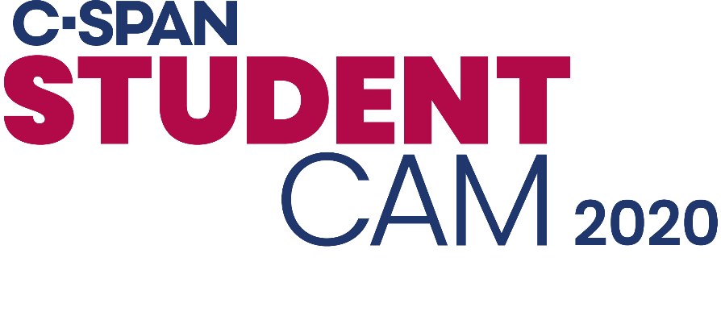
Social Media Ideas:

Social media is an easy and great way to acknowledge your local winners and build your brand as a supportive participant in local educational efforts. By recognizing their hard work, students will see the value in their documentaries that help highlight their schools and communities. Below you will find some ideas and samples you can post on Twitter, Instagram and Facebook.

Twitter:
It's been 16 years of @StudentCam and we are excited to congratulate our (# of winners) winner(s) from (school handle)! Check out the winning video below #StudentCam2020 (Include: hyperlink of video)

JUST IN: (school or student handle) has placed in this year's @studentcam! We are proud to congratulate our (Grand Prize, First Prize, Second Prize, Third Prize, HM) winner(s)! #StudentCam2019 (Include: a screen shot of the student's video in your tweet)

Congratulations on your @studentcam winners from (School handle)! We are honored to celebrate you on this amazing accomplishment- check out their video below! #StudentCam2020

We are proud to recognize (school handle) on their @studentcam winners! - way to go! #StudentCam2020 (Include: a screen shot of the students video in your tweet)

Instagram:
A big congratulation to (names) from (school name) who placed in @cspanstudentcam 2020 competition! These students are among the 150 winners nationwide! C-SPAN's national documentary contest received 2,526 entries and over 5,389 student participants in 44 states and Washington, D.C. (hashtags: #cspan #studentcam2020 #documentarycontest #prize)

Facebook:
A huge congratulation to (student's names) from (school) who placed in C-SPAN's annual documentary contest, StudentCam! (Your cable company) was proud to partner with C-SPAN on StudentCam this past year, and we are excited to highlight our winner(s). This competition allowed students in grades 6-12 to put together a 5-6 minute documentary answering, “WHAT'S YOUR VISION IN 2020? Explore the issue you most want presidential candidates to address during the campaign." Out of 2,526 entries and over 5,389 student participants, (students' names) from (school) were chosen among the 150 winners nationwide!

